Path Exploration for Event Analytics

1. Overview
The Path Exploration (reference: GA4 ) using event-level data (event_id). It reconstructs a user’s event journey step-by-step, by ordering their actions chronologically and dynamically generating nodes to represent each step.

2. Term

Session Definition

A new session begins if a user is inactive for 30 minutes.
- Path exploration for each user limits the path length: 100 in cases where redundant nodes are not removed, and a flexible number (always ≤ 100) in cases where they are.

Supported Node Types

The system supports 4 flexible node types for building path explorations: event_name, screen_name, miniapp_id, service_name, feature_code. (feature_code bổ sung sau ver 1)

Users can dynamically switch node types at each step in the path, and the query logic updates the node_value accordingly.

Segment Definition:

Segments are created by joining demographic and attribute data with user_id. This allows for targeted path analysis on subsets of users based on attributes like location, age group..

Dimension Options:

The path exploration can be filtered or grouped by these dimensions: device_os, app_version, miniapp_version, build_number.

These dimensions enable breakdowns of user journeys by technical environment or app versioning.

3. Logic Flow
- Sample 10% of data by user_id per hour: reduce data size while keeping behavior representative.
- Filter by valid event_name list: keep only events relevant for analysis.
- Create sessions using 30-minute inactivity rule: new session starts if no event within 30 minutes.
- Forward-fill empty fields within each session (screen_name, service_name, miniapp_id, event_name): use the most recent non-empty value from earlier in the session.
- Filter out sessions/events that still have missing values

5. Functional Behavior When User Interacts with the Path Exploration Chart
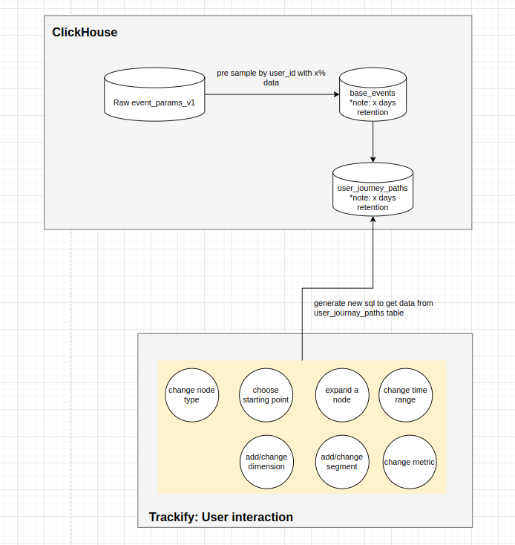

New Approach

WITH session_arrays AS (
-- B1: Gom mảng gốc từ session_id có sẵn (30p không có action thì ngắt)
SELECT
session_id,
user_id,
groupArray(if(app_id = '', 'empty', app_id)) AS all_apps,
groupArray(
concat(
if(app_id = '', 'empty', arrayElement(splitByChar('.', app_id), -1)),
' ',
if(screen_name = '', 'empty', screen_name)
)
) AS all_screens,
groupArray(if(event_name = '', 'empty', event_name)) AS all_events,
groupArray(if(service_name = '', 'empty', service_name)) AS all_services
FROM apollo.base_events
WHERE db_arrival_time between '2025-12-15 00:00:00' and '2025-12-16 00:00:00'
GROUP BY session_id, user_id
),
sliced_paths AS (
-- B2: Tìm vị trí đầu tiên của step 1 và cắt mảng
SELECT
user_id,
session_id,
-- Tìm vị trí của step đầu tiên user config
indexOf(all_apps, 'vn.momo.mobilecenter') AS start_idx,

-- Chỉ xử lý tiếp nếu tìm thấy step 1 trong session
-- Cắt mảng từ start_idx đến hết
arraySlice(all_apps, start_idx) AS apps,
arraySlice(all_screens, start_idx) AS screens,
arraySlice(all_events, start_idx) AS events,
arraySlice(all_services, start_idx) AS services
FROM session_arrays
WHERE start_idx > 0
),

--config
-- step 1: app
-- step 2: app
-- step 3: app
-- step 4: screen
-- step 5: screen
-- step 6: screen
-- step 7: event
-- step 8: event
-- step 9: app
-- step 10: app

path_indexing AS (
-- B3: Dùng logic giữ lại idx của step liền trc trên mảng đã cắt (idx lúc này luôn bắt đầu từ 1)
SELECT
user_id,
session_id,
apps[1] AS s1,

arrayFirstIndex(i -> apps[i] != s1, arrayEnumerate(apps)) AS i2,
apps[i2] AS s2,

arrayFirstIndex(i -> i > i2 AND apps[i] != s2, arrayEnumerate(apps)) AS i3,
apps[i3] AS s3,

-- Chuyển node type ở vị trí nào thi idx = idx cũ từ vị trí đó
i3 as i4,
screens[i4] AS s4,

arrayFirstIndex(i -> i > i4 AND screens[i] != s4, arrayEnumerate(screens)) AS i5,
screens[i5] AS s5,

arrayFirstIndex(i -> i > i5 AND screens[i] != s5, arrayEnumerate(screens)) AS i6,
screens[i6] AS s6,

i6 as i7 ,
events[i7] as s7,

arrayFirstIndex(i -> i > i7 AND events[i] != s7, arrayEnumerate(events)) AS i8,
events[i8] AS s8,

i8 as i9,
apps[i9] as s9,

arrayFirstIndex(i -> i > i9 AND apps[i] != s9, arrayEnumerate(apps)) AS i10,
apps[i10] AS s10

FROM sliced_paths
)

SELECT
s1 AS step_1,
s2 AS step_2,
s3 AS step_3,
s4 AS step_4,
s5 AS step_5,
s6 AS step_6,
s7 AS step_7,
s8 AS step_8,
s9 AS step_9,
s10 AS step_10,
count(distinct user_id) AS user_cnt,
count(distinct session_id) session_cnt
FROM path_indexing
WHERE step_1 = 'vn.momo.mobilecenter'
and step_2 = 'vn.momo.platform'
and step_3 = 'vn.momo.payx'
and step_4 = 'payx payment'
and step_5 = 'platform Payment Confirm'
and step_6 = 'payx result'
and step_7 = 'feature_trans_result'
and step_8 = 'auto_screen_navigated'
and step_9 = 'vn.momo.platform'
GROUP BY 1, 2, 3, 4, 5, 6, 7, 8, 9, 10
ORDER BY 11 DESC
settings max_threads = 16

New template

Lấy giá trị starting point theo mỗi node type | @node_type:  events => query event_name  screens => screen_name,  apps => app_id,  services => service_name  SELECT @node_type AS value  FROM apollo.@node_type  settings max_threads = 16 | @node_type: screens  SELECT screen_name  FROM apollo.screen_name
Expand node | /*  Replace placeholders:  {{START_NODE_TYPE}} = events | screens | apps | services  {{STARTING_POINT}} = your starting value  {{DATE_FROM}} = start date  {{DATE_TO}} = end date  {{STEP_N_TYPE}} = node type for each step  {{metric_type}} = metric type (session, user)  */  WITH  base AS (  SELECT  user_id,  session_id,  arraySlice(all_apps, indexOf(all_{{START_NODE_TYPE}}, '{{STARTING_POINT}}')) AS apps,  arraySlice(all_screens, indexOf(all_{{START_NODE_TYPE}}, '{{STARTING_POINT}}')) AS screens,  arraySlice(all_events, indexOf(all_{{START_NODE_TYPE}}, '{{STARTING_POINT}}')) AS events,  arraySlice(all_services, indexOf(all_{{START_NODE_TYPE}}, '{{STARTING_POINT}}')) AS services  FROM apollo.session_arrays_v2  WHERE event_date BETWEEN '{{DATE_FROM}}' AND '{{DATE_TO}}'  AND has(all_{{START_NODE_TYPE}}, '{{STARTING_POINT}}')  AND indexOf(all_{{START_NODE_TYPE}}, '{{STARTING_POINT}}') > 0  ),  paths AS (  SELECT  user_id,  session_id,  -- Step 1: {{STEP_1_TYPE}} [START]  {{STEP_1_TYPE}}[1] AS step_1,  -- Step 2: {{STEP_2_TYPE}} [NEXT or SWITCH]  -- If NEXT (same type as step 1):  arrayFirstIndex(i -> {{STEP_2_TYPE}}[i] != step_1, arrayEnumerate({{STEP_2_TYPE}})) AS i2,  -- If SWITCH (different type):  1 AS i2,  {{STEP_2_TYPE}}[i2] AS step_2,  -- Step 3: {{STEP_3_TYPE}} [NEXT or SWITCH]  -- If NEXT:  arrayFirstIndex(i -> i > i2 AND {{STEP_3_TYPE}}[i] !=step_2, arrayEnumerate({{STEP_3_TYPE}})) AS i3,  -- If SWITCH:  i2 AS i3  {{STEP_3_TYPE}}[i3] AS step_3  …..  -- Step n: {{STEP_n_TYPE}} [NEXT or SWITCH]  -- If NEXT:  arrayFirstIndex(i -> i > i(n-1) AND {{STEP_n_TYPE}}[i] !=step_(n-1), arrayEnumerate({{STEP_n_TYPE}})) AS i(n),  -- If SWITCH:  i(n-1) AS i(n)  {{STEP_3_TYPE}}[i(n)] AS step_n  FROM base  )  SELECT step_1, step_2, step_3,  count(DISTINCT {{metric_type}}) AS value  FROM paths  WHERE step_1 != ''  GROUP BY ALL  ORDER BY value DESC  settings max_threads = 16 | /*  Config:  START_NODE_TYPE = apps  STARTING_POINT = ''vn.momo.mobilecenter''  DATE_FROM = '2025-12-15 17:00:00'  DATE_TO = '2025-12-16 17:00:00'  STEP_1_TYPE = apps  STEP_2_TYPE = apps [NEXT]  STEP_3_TYPE = apps [NEXT]  STEP_4_TYPE = screens [SWITCH]  STEP_5_TYPE = screens [NEXT]  METRIC_TYPE = user_id  */  WITH  base AS (  SELECT  user_id,  session_id,  arraySlice(all_apps, indexOf(all_apps, 'vn.momo.mobilecenter')) AS apps,  arraySlice(all_screens, indexOf(all_apps, 'vn.momo.mobilecenter')) AS screens,  arraySlice(all_events, indexOf(all_apps, 'vn.momo.mobilecenter')) AS events  FROM apollo.session_arrays_v2  WHERE event_date BETWEEN '2025-12-15 17:00:00’' AND '2025-12-16 17:00:00'  AND has(all_apps, 'vn.momo.mobilecenter')  ),  paths AS (  SELECT  user_id,  session_id,  apps[1] AS step_1,  --step 2 vẫn giống node type với step trước đó  arrayFirstIndex(i -> apps[i] != step_1, arrayEnumerate(apps)) AS i2,  apps[i2] AS step_2,  --step 3 vẫn giống node type với step trước đó  arrayFirstIndex(i -> i > i2 AND apps[i] != step_2, arrayEnumerate(apps)) AS i3,  apps[i3] AS step_3,  --step_4 chuyển node type  i3 as i4,  screens[i4] AS step_4,  --step 5 vẫn giống node type với step trước đó  arrayFirstIndex(i -> i > i4 AND screens[i] != step_4, arrayEnumerate(apps)) AS i5,  screens[i5] AS step_5  FROM base  )  SELECT step_1, step_2, step_3,step_4, step_5,  count(DISTINCT user_id) AS value  FROM paths  WHERE step_1 != ''  and step_2 ='vn.momo.platform'  and step_3 ='vn.momo.payx'  and step_4 ='payx payment'  GROUP BY ALL  ORDER BY value DESC  settings max_threads = 16
Thêm segment |  | WITH  base AS (  SELECT  user_id,  session_id,  arraySlice(all_apps, indexOf(all_apps, 'vn.momo.mobilecenter')) AS apps,  arraySlice(all_screens, indexOf(all_apps, 'vn.momo.mobilecenter')) AS screens,  arraySlice(all_events, indexOf(all_apps, 'vn.momo.mobilecenter')) AS events  FROM apollo.session_arrays_v2 ev  join (select distinct user_id  from apollo_segment.bq_freq_samplesegment_all  where segment_id = 'BQ_FREQ_SampleSegment_large') se  using (user_id)  WHERE event_date BETWEEN '2025-12-15' AND '2025-12-16'  AND has(all_apps, 'vn.momo.mobilecenter')  )

